**Sprint Goal:** Interacting with and saving the state of cellular automata. Plus starting backend implementation.

**Spikes:**

* Spike 1: Database research (Firebase?)
* Spike 2: User Authentication
* Spike 3: UX Design for pages

**User story tasks:**

* **User story 1 (save):** As a creator, I want to be able to save the state of my cellular automaton.
  + Build a database (3 hours)
    - Host a database
  + Export data from p5 (2 hours)
  + Sending data to the middleware and then to the database (2 hours)
  + Total: 7 hours
* **User story 2 (welcome):** As a viewer, I want to read a welcome page, so that I can understand cellular automata and what this thing does.
  + Background with CA gif (maybe Rule 30, maybe square game of life) (1 hour)
  + Logo (less 1 hour)
  + Description of what Cellular Automata is (less 1 hour)
  + Start direct to simulation (less 1 hour)
  + Total: 2 hours
* **User Story 3** **(shaderlang)**: As a builder, I want to write CA as a shader language so that I can create my own performant CAs.
  + Python prototype (1 hours)
  + Integrate prototype in p5 development environment (2 hours)
  + Write shaderlang in JavaScript (2 hours)
  + Integrate shaderlang in right-hand tabs (1 hour)
  + Find react component code editor (1 hour)
  + Total: 7 hours
* **User story 4 (pause):** As a builder, I want to be able to pause the simulation so that I can view the current state.
  + Pause and stop CA animation (edit inbetween) (2 hour)
  + Change state while paused (2 hour)
  + Start CA animation again from current state (2 hour)
  + Total: 6 hour
* **User story 5 (db_login):** As a User I want to be able to log in to a user account, so that I can save my session data and creations.
  + Spike - google implementation?
  + Implement feature in backend (2 hours)
* **User story 6 (db_post):** As a User I want to be able to make posts so that I can share my creations with other users.
  + Implement feature in backend (2 hours)
* **User story 7 (db_sort):** As a User I want to be able to sort and search for other users posts to see what others in the community have created
  + Implement feature in backend (2 hours)
* **Previous - Sprint 1 (1D in 2D):**
  + Stack 1D in 1D on top of each other (2 hours)
* **Previous - Sprint 1 (Custom Cursor):**
  + Has some bugs: circle is not centered (less 1 hour)

**Team Roles:**

Kevin Schultz: Product Owner

Ethan Foster: Team Member

Preston Nguyen: Scrum Master

Alexander Garza: Team Member

Beckett Avary: Team Member

**Initial Task Assignment:**

Kevin Schultz:

* Raycasting Mouse Coordinate mapping
* Side Bar
* Options inside side bar for premade
* Premade Rules
* Brush Types
* 1D in 2D

Ethan Foster:

* Backend interface
* Database api
* Premade rules
* Save
* welcome

Preston Nguyen:

* Finish custom cursor
* Welcome Page
* Fix side bar

Alexander Garza:

* 1D in 2D
* Pause

Beckett Avary:

* Shaderlang
* Shaderlang_proto

**Burnup chart:**

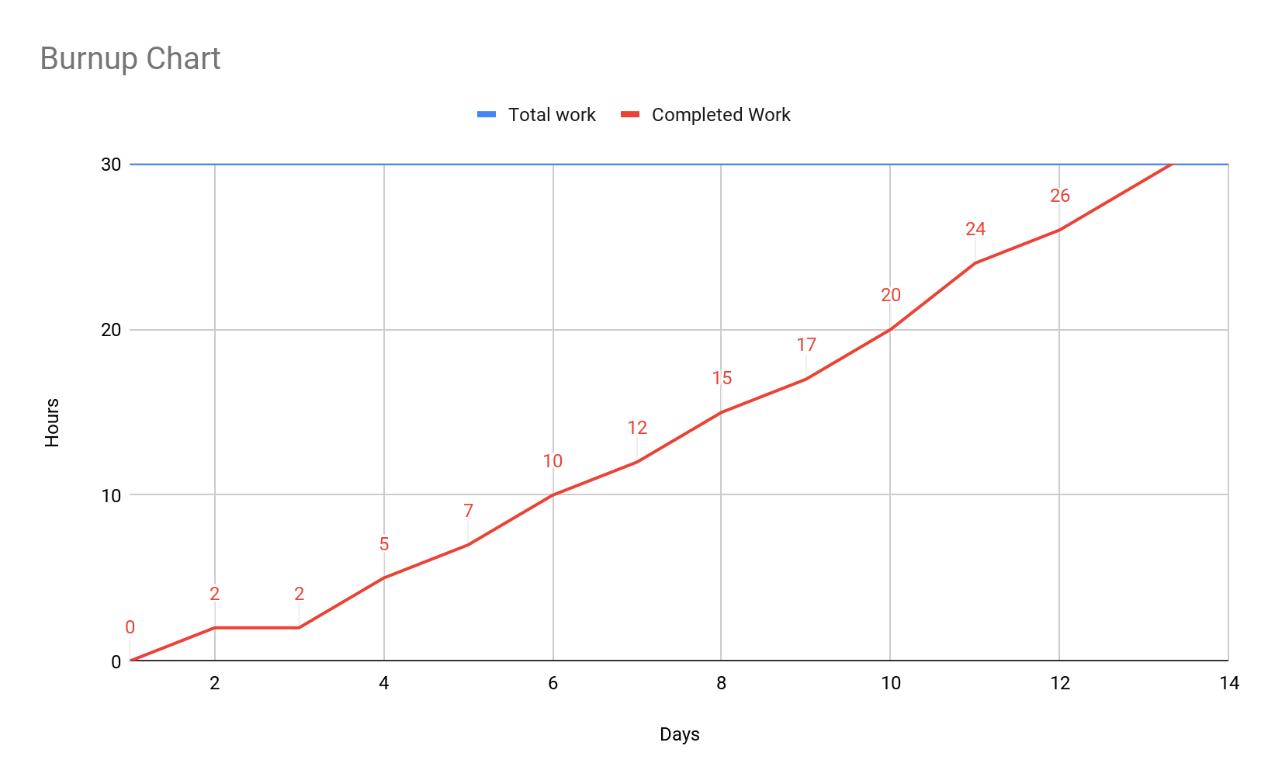

**Prioritize user stories:**

1. User story 6
2. User story 7
3. User story 8
4. User story 1
5. User story 2
6. User story 4
7. User story 3
8. User story 5
9. User story 9
10. User story 10

**Backlog**

1. Fullscreen

**Scrum Board:**

<https://jamboard.google.com/d/1WuecReEvjC3s1jhugJyICtRss0PQq9s4udIiGU8Cr9I/edit?usp=sharing>

**Scrum meeting times:**

Mon: 3:00

Wed: 4:00

Fri: 3:00